Below is the simplest possible flowchart for the project. You are expected to include more details and assumptions.

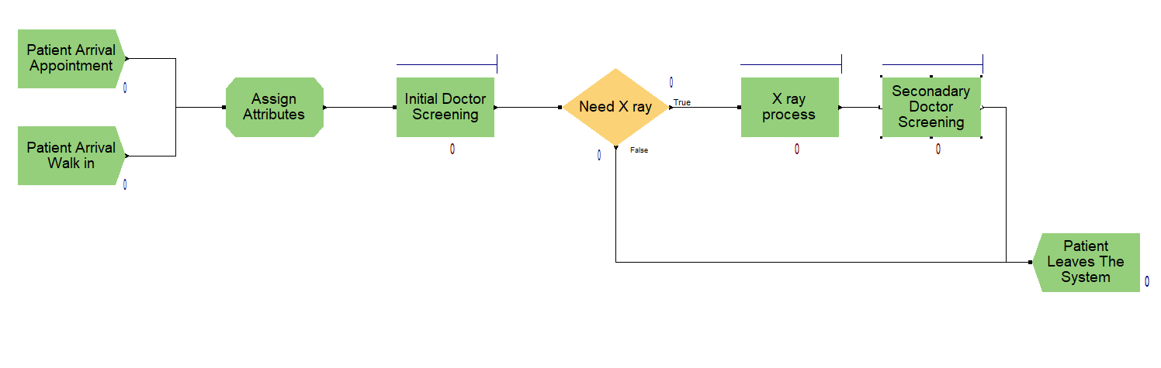
Arrivals with appointment follow a particular schedule. This schedule is an input (see some examples below). Your code needs to be adjustable with respect to different schedules. Patients arrive at a random time (with respect to their scheduled time)
Arrivals without appointment follow a distribution which you need to determine.
There are n departments: Hand, control, tumor, child, etc. There are 7 rooms and departments have a weekly schedule. Not all departments are working on every day. On a particular day we have multiple departments. Each department and doctor has a different schedule.
A patient needs X-ray with some probability (which you need to estimate with respect to the department)
You need to determine (or assume) the way the queues work for the initial screening, secondary screening, and X-ray. (i.e. FIFO, LIFO, priority queue). Your code needs to be adjustable for new rules.
The secondary screening (if need be) needs to visit the same doctor.
Any additional assumptions and calculations such as travel times, number of people with the patient, inter screening times need to be defined clearly.
Feel free to update the above chart to include additional detail.
Schedules need to be determined as follows:
Name
Schedule 1 | every 6 minutes from 08:00 to 12:00 and from 13:00 to 16:00
Schedule 2 | every 6 minutes from 08:00 to 10:00 and every 10 minutes from 10:00 to 12:00, every 8 minutes from 13:00 to 15:00 and every 10 minutes from 15:00 to 16:00,
Schedule 3 | every 6 minutes from 08:00 to 10:00 and every 8 minutes from 10:00 to 12:00

For the above schedule 1, we have appointments at 08:00, 08:06, 08:12, 08.18, … 11:48, 11:54 for the morning session.
You need to keep track of at least (but not limited to) the following performance metrics: average number of people in queue, average waiting time, maximum waiting time.
Things you need to clarify including but not limited to:
What happens when the time is noon or end of day and there are patients waiting for the doctor or X-ray.
How the queue works if there are patients waiting with and without appointment at the same time

